Lab tasks 9:

**Q1:**

Code: 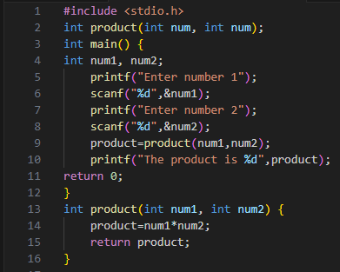

Output: 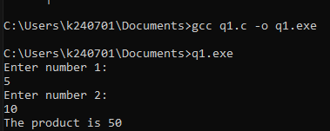

**Q2:**

Code: 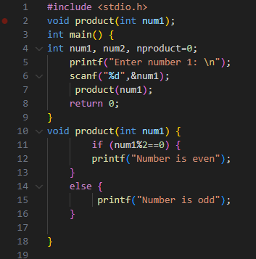

Output: 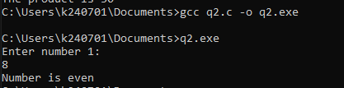

Q3:

Code: 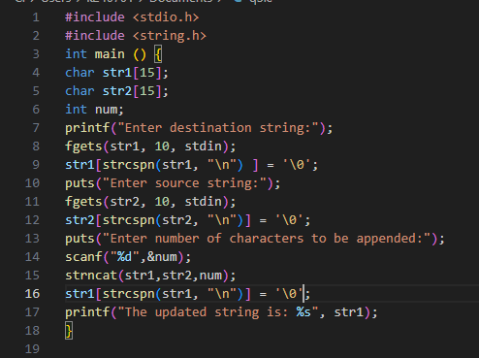

Output: 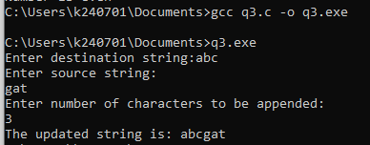

**Q4:**

**Code:** 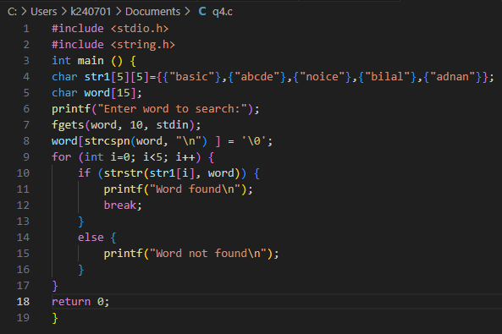

**Output:** 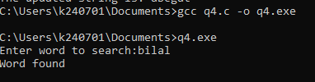

**Q5:**

**Code:**

#include <stdio.h>

#include <string.h>

int main () {

int length, flag=1;

char word[5][20]={0};

for (int i=0; i<5; i++) {

    printf("Enter word %d:",i+1);

fgets(word[i], 20, stdin);

word[i][strcspn(word[i], "\n")] = '\0';

}

for (int k=0; k<5; k++) {

    flag=1;

    length=strlen(word[k]);

for (int i=0; i<length/2; i++) {

    if (word[k][i]!=word[k][length-1-i]) {

    flag=0;

    break;

    }

   }

    if (flag==1) {

  printf("The word %s is a palindrome\n",word[k]);

    }

    else {

     printf("The word %s is NOT a palindrome\n",word[k]);

    }

}

return 0;

}

**Output:** 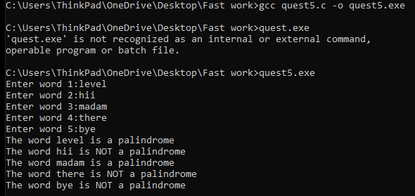

Q6:

Code: 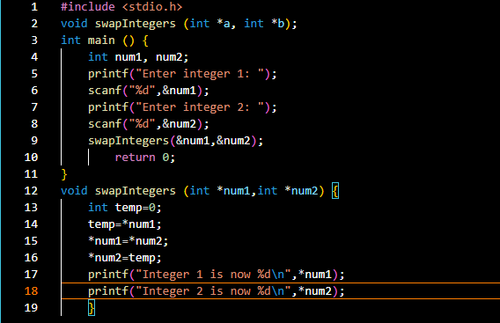

Output: 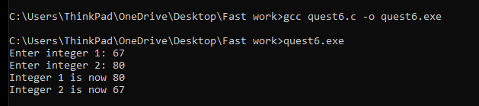

Q7:

Code: 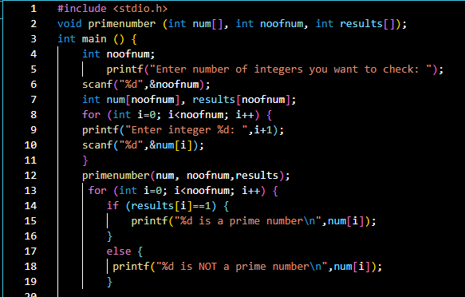

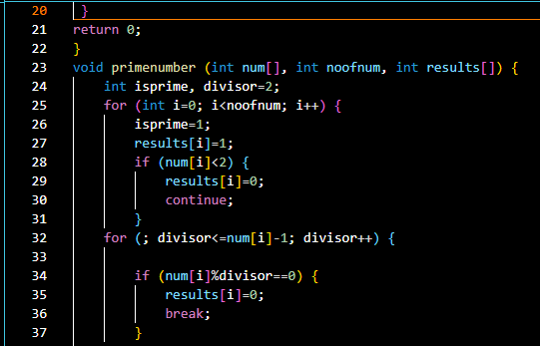

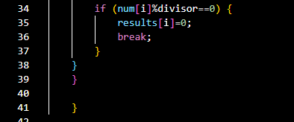

Output: 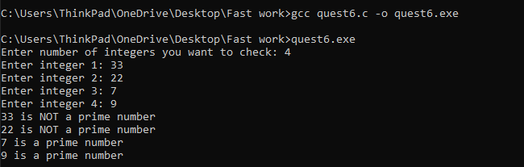

Q8:

Code: 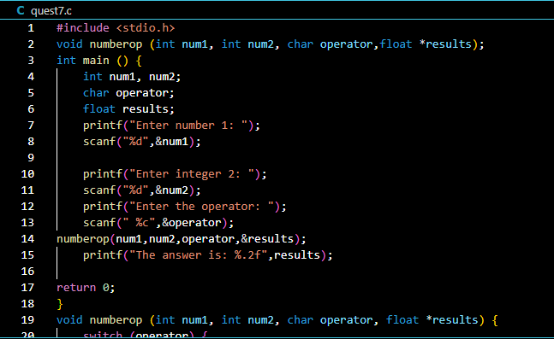

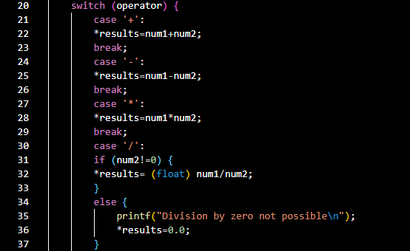

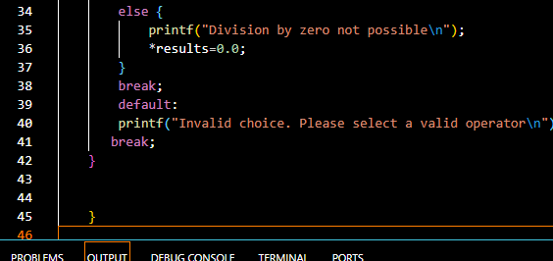

Output: 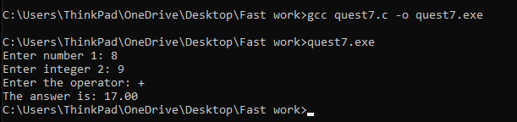

Q9

Code: 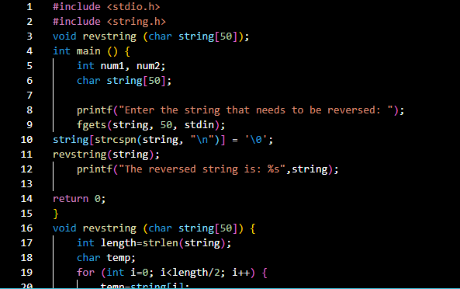

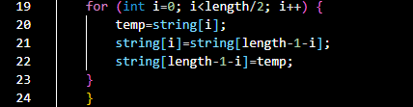

Output: 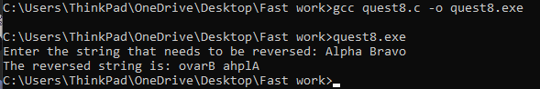

Q10

Code: 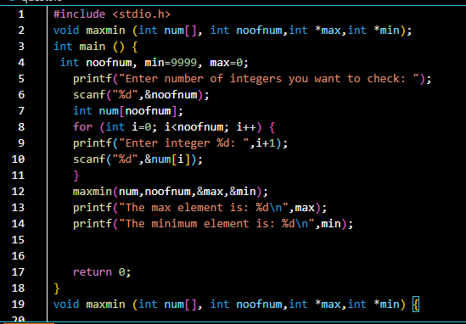

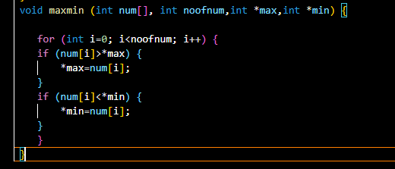

Output: 